* document OS server is running under, command for stopping, starting server

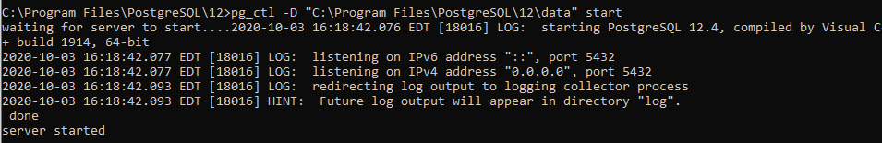

* document command for emergency stop of server; What happens to existing users and data?



All transactions are aborted, and all connections are disconnected.

* re-upload the configuration file; show log file afterwards, from CLI you can just output the bottom of the log file





* show restriction of all users to database, set connection limits to 0



* show how to restrict users to a single session



* create a second database using same instance of the existing PostgreSQL



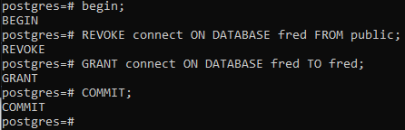

* show the creation of multiple namespaces

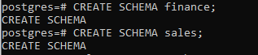

* install PgBouncer - connection pool manager



* show PgBouncer working - simple command output sufficient

